Sun Roofs

With our control units, we offer advanced and sophisticated technical solutions for modern high quality vehicles. Our products range from standard control units for the sliding section of the roof to complex multi-motor systems to operate large panorama roofs.

### Functions

* Standalone solutions
* Motor-integrated solutions
* Master-slave control and multi-slave control for multi-motor systems
* Sunshade control
* Anti-pinch protection
* One-touch opening and closing
* Thermal motor protection
* Possibility to integrate switches (e.g. sunroof/sunshade switches), interior lighting control, interior rear view mirror control (EC glass), etc.

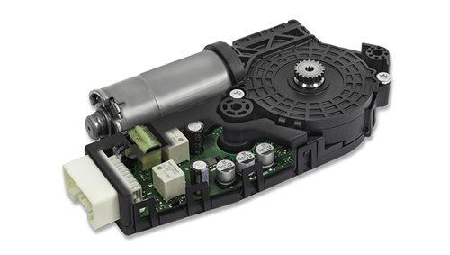

Advantages

* High performance anti-pinch protection
* Tilting/Sliding
* Short development phases and fast time to market cycles thanks to modular design
* Worldwide support for vehicle parameter adjustments
* Extensive experience as world's top manufacturer of sunroof control units with anti-pinch protection

**KOSTAL Switch Control**

KOSTAL roof modules combine a wide variety of individual components in a single module. The company’s expertise in switch panels, mechanical, electronic and software fields, lighting technology and simulation techniques make KOSTAL the ideal partner in the development of optimum-interface mechatronic modules.

KOSTAL Dachmodule

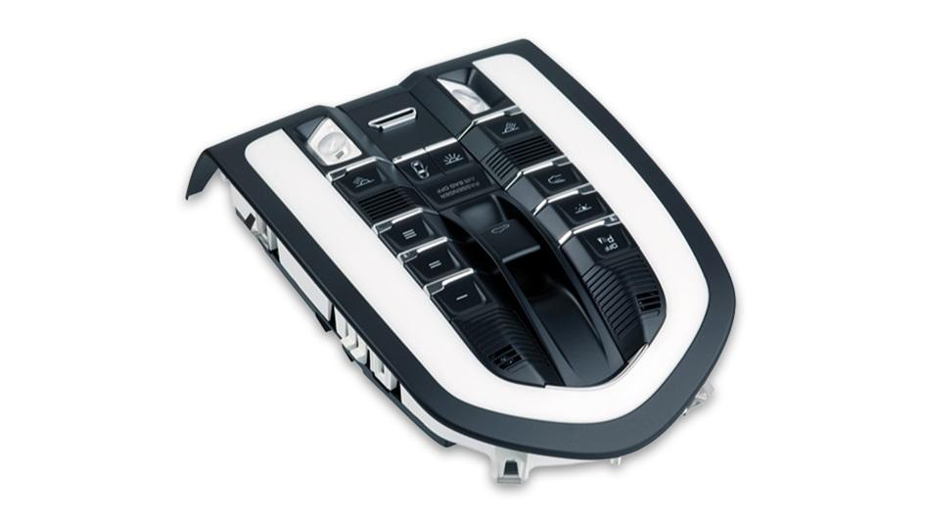

BLOCK DIAGRAM

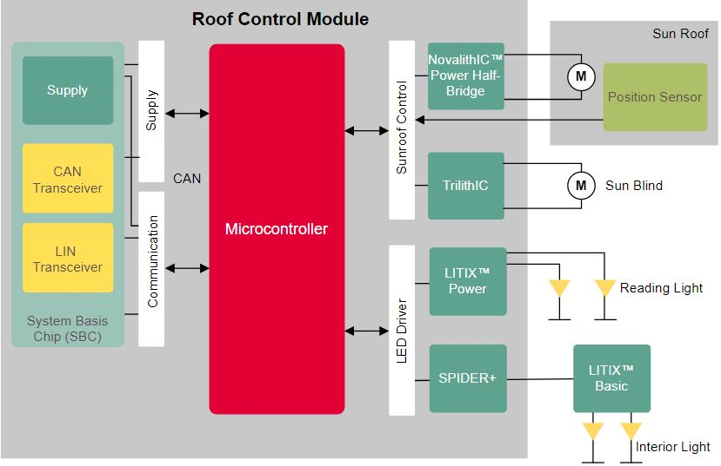

1. **Position Sensor:** For sensing the position of sunroof and also if some object is in between te sunroof and body of the car. Here the **ENSIV™ - TLE4961-3K** sensor is used.

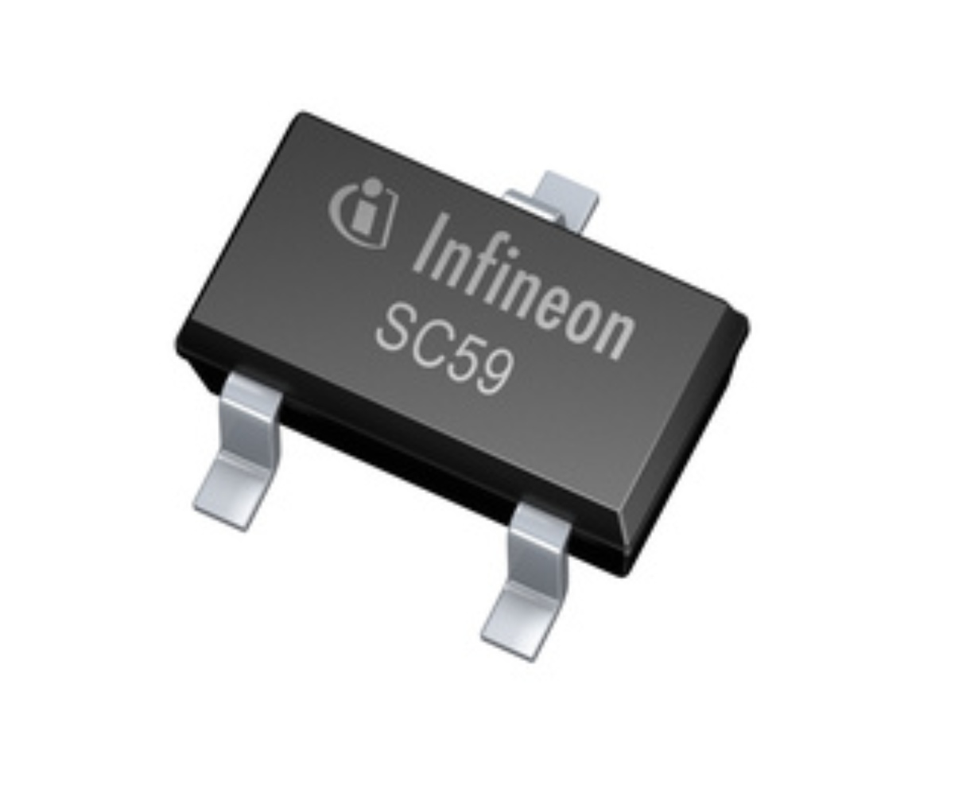

2.Trilith IC : This IC is used to operate the sunshade motor. Here **BTM7740G** is part of the Trilith IC family containing three dies in one package:

One double high-side switch and two low-side switches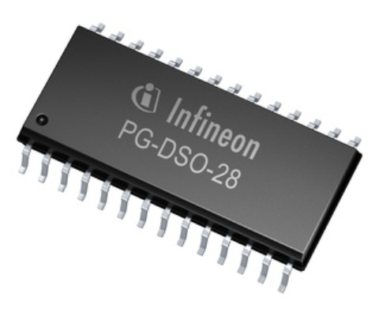

3.Novalith Power Half Bridge: This IC is used to operate the sunroof motor. Here BTN8962TA is used as it is an integrated high current half bridge for motor drive application

